Doctor ^{[16]}:
- Proportion: 43.9% of doctors were female in 2023.
- 95% uncertainty interval: 34.5%–53.2%.

Teachers ^{[17]}:
- In 2020
- teachers in pre-primary – 94% female
- teachers in primary – 67% female
- teachers in lower-secondary – 57% female
- teachers in upper-secondary education – 50% female
- teachers in tertiary sector – 44% female

Farmers ^{[18]}:
- 37% of people employed in agriculture, forestry and fishing worldwide were women in 2021.
- This represents 317 million women employed in the sector, compared with 544 million men.

Construction ^{[19]}:
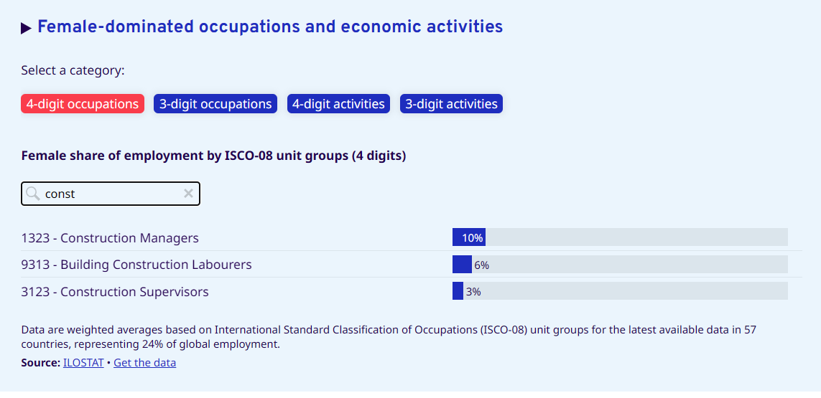
Partial coverage: It covers 57 countries, about 24% of global employment, not a global figure.

CEOs ^{[20]}:
8% of CEOs at some of the world’s largest listed companies are women. The sample is 1,221 CEOs in 27 markets as of 30 June 2023.

Scientist ^{[21]}:
- Using 147 countries reporting since 1996, 31.7% women researchers globally in 2021
- Using only the 95 countries reporting headcounts for 2018-2021, the figure is 33.7%.

